Marks : 8
Total_Mark column is not calculated
Insight missing

library(readxl)
library(dplyr)
library(ggplot2)
library(cowplot)
##First install the libraries and load then

S_p = read_excel("D:/Study/PDS/input/StudentsPerformance.xlsx")

head(S_p)
tail(S_p)
summary(S_p)
View(S_p)
str(S_p)
nrow(S_p)
print(S_p)

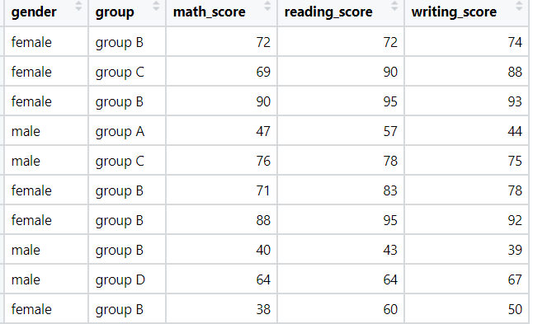
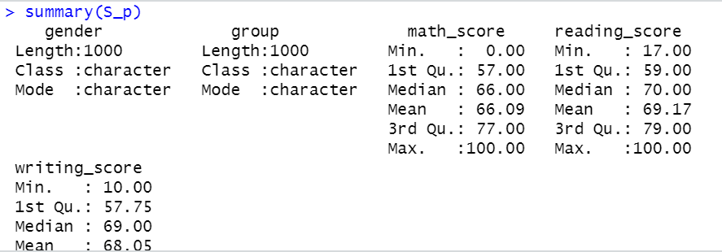
##Function like head, tail, summary, view, str, nrow are used to get the descriptive analysis of the dataset

S_p %>% filter(is.na(group))
S_p %>% filter(is.na(gender))
S_p %>% filter(group == 'group D' & reading_score >= 20)
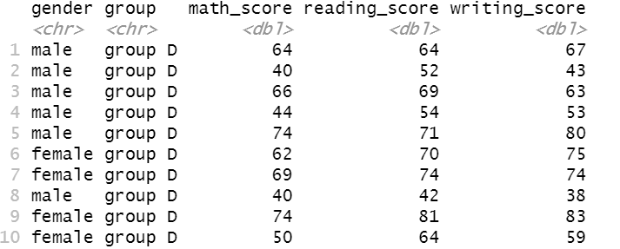

##Function filter is used to filter out specific needs from the datasets
new_S_p = mutate(S_p,average_score = round((math_score+reading_score+writing_score)/3))
new_S_p$average_score
head(new_S_p)
summary(new_S_p)
View(new_S_p)
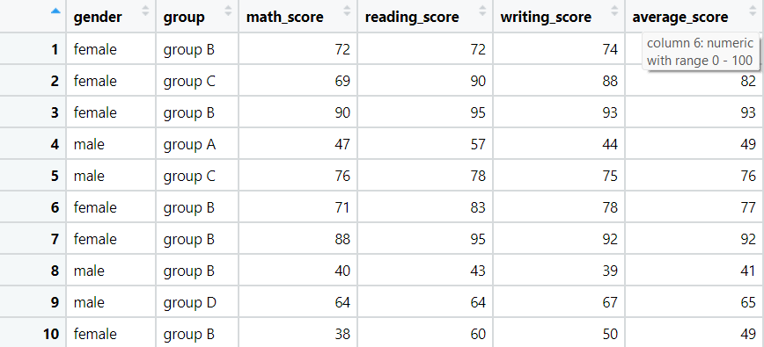
##Function mutate is used to change or modify data in dataset and add new columns
avg_math_performance = aggregate(new_S_p$math_score, list(S_p$group), FUN=mean)
colnames(avg_math_performance) <- c('group','avg_math_performance')
avg_math_performance

avg_reading_performance = aggregate(new_S_p$reading_score, list(S_p$group), FUN=mean)
colnames(avg_reading_performance) <- c('group','avg_reading_performance')
avg_reading_performance

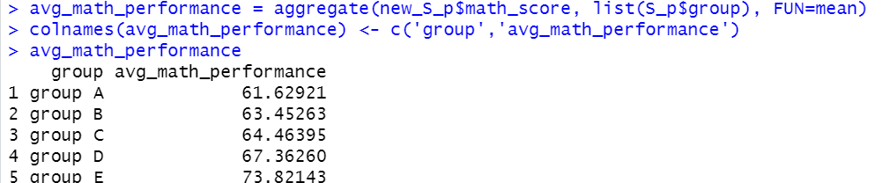

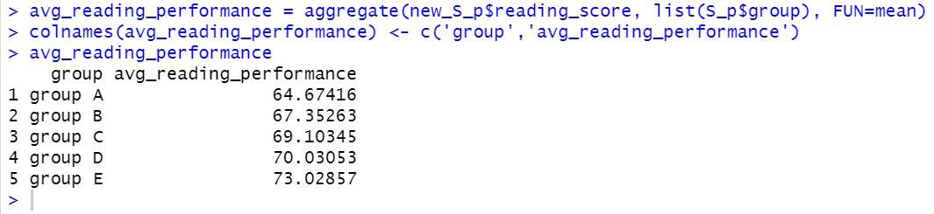
##Aggregate() Function in R Splits the data into subsets, computes summary statistics for each subsets and returns the result in a group by form.
##FUN represents sum/mean/min/ max.
ggplot(avg_math_performance, aes(x=group, y=avg_math_performance, fill=group)) +
geom_bar(stat="identity") + labs(x="Groups", y="avg_math_performance")
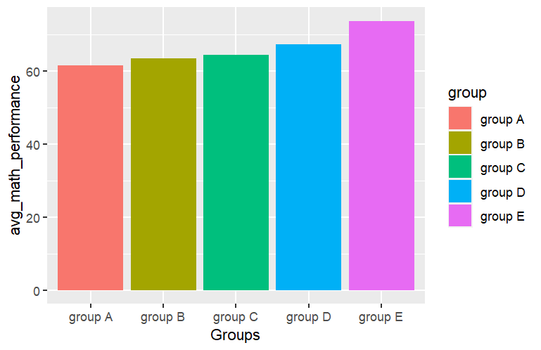

ggplot(avg_reading_performance, aes(x=group, y=avg_reading_performance,fill=group)) +
geom_bar(stat="identity") + labs(x="Groups", y="avg_reading_performance")
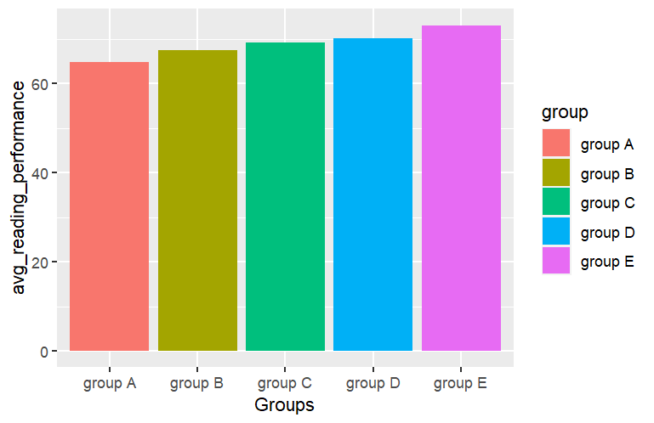

ggplot(avg_writing_performance, aes(x=group, y=avg_writing_performance,fill=group)) +
geom_bar(stat="identity") + labs(x="Groups", y="avg_writing_performance")

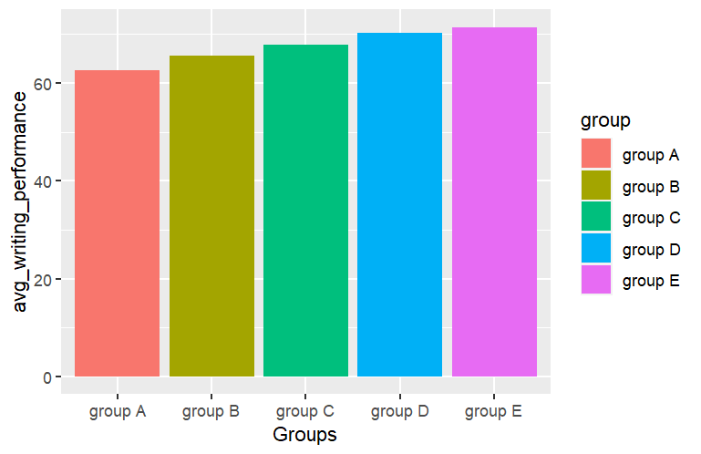

##Add a new column “total mark” and analyze the group performance with respect to Total Marks

total_marks = mutate(S_p,total_score = (math_score+reading_score+writing_score))
total_marks$total_score
head(total_marks)

grp2_max = total_marks %>% group_by(group,gender) %>%
summarise(sum_total = sum(total_score))
grp2_max

ggplot(grp2_max,(aes(x=group,y=sum_total,fill=gender))) +
geom_bar(stat = "identity",position = "dodge")

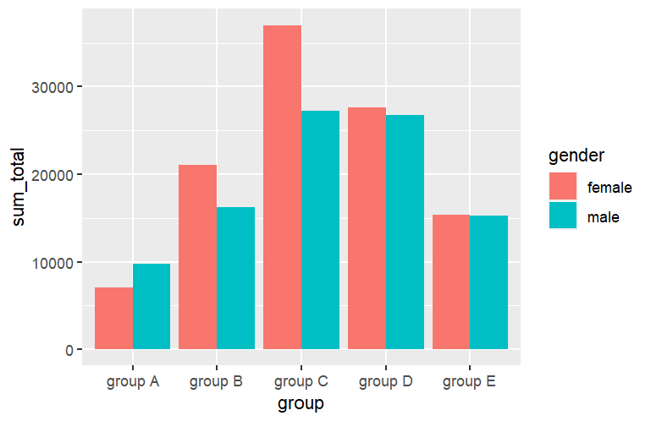

ggplot(total_marks,(aes(x=group,y=total_score,fill=gender))) +
geom_bar(stat = "identity",position = )

